|  |  |  |
| --- | --- | --- |
| **Workshop 3** | **Type:** | **workshop** |
| **Code:** | **Pro192** |
|  |  |
| **Slot(s):** | **5-6-7** |

1. **Knowledge required**: Concept of Class, Object, Field, Property, Method, Constructor, ArrayList.
2. **Learning Outcome:**

* Apply Data abstraction to declare Class.
* Know how to build Class, initialize and use objects in Java.
* Applying encapsulation in OOP using access modifier and package organization.
* Practice coding and solving problems from the perspective of object-oriented programming.

1. **Content**
2. Rewrite the following classes and fix all errors for the program

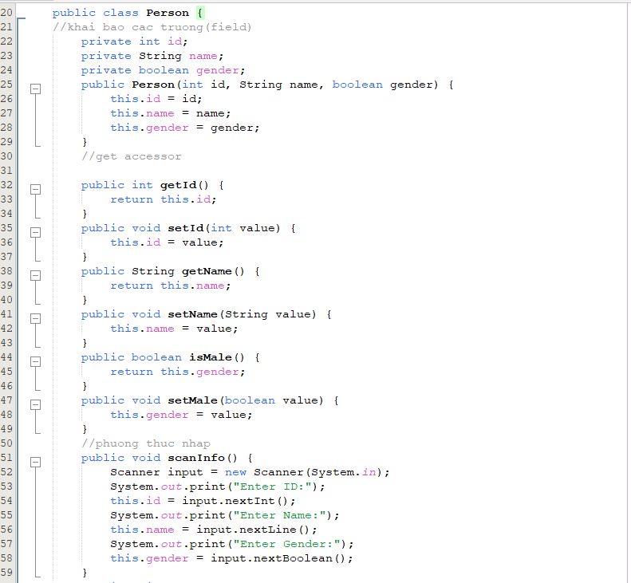

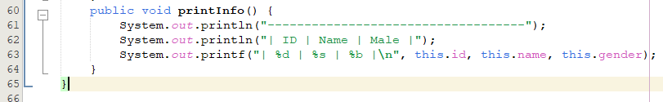

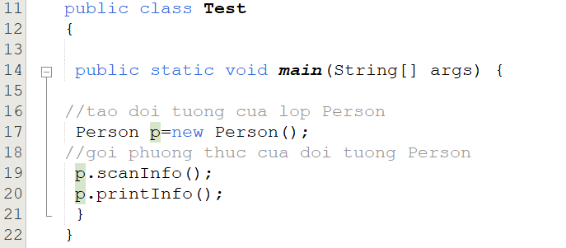

1. Write scanInfo() and print intInfo() input function outside of Person class, fix the error to make the program run with the result as shown below:

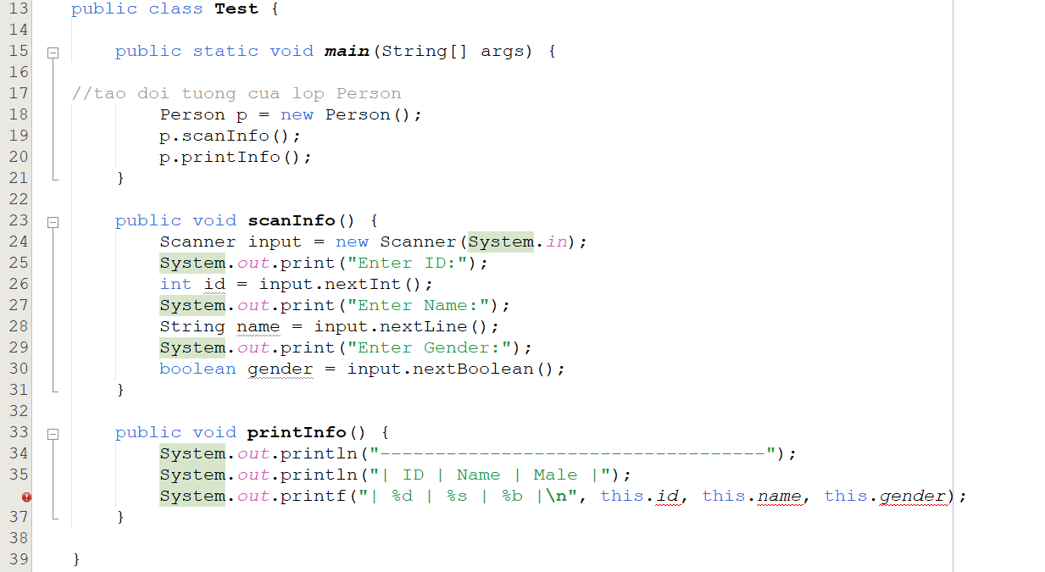

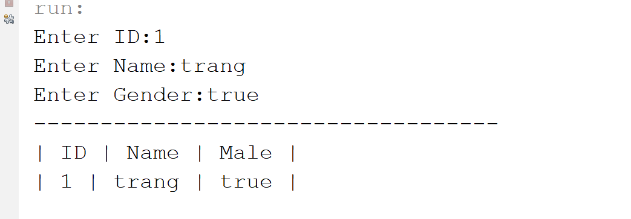

1. Use the code of the exercise 2 to write additional code to fulfill the following requirements:

* In class Test, initialize 2 more objects of Person class (Note: use constructor with value initialization arguments for Person class properties);

Example: Person p=new Person (01,"Nguyen Van A”, true);

* Declare an array named perArr with length = 4, assign the above 2 objects to the first 2 elements of the array;
* Write code allows the user to enter values for the remaining 2 elements of the array, traverse the array, and print out the elements of the array.

1. Use the code of the exercise 2 to write additional code to fulfill the following requirements:

* In class Test, Declare an ArrayList type of Person: initialize 2 more objects of Person class (Note: use constructor with value initialization arguments for Person class properties), use method add () for store above 2 objects in ArrayList;
* Write code allow user input data and initialize 2 more person objects save to the ArrayList;
* Write function sort ArrayList by name only (Note: Use only the knowledge that you have learned).
* Write function search an object in Array List by name ((Note: Use only the knowledge that you have learned).

1. Rubric

|  |  |
| --- | --- |
| **Criteria** | **Score** |
| Lesson 1 | 1 |
| Lesson 2 | 2 |
| Lesson 3 | 3 |
| Lesson 4 | 4 |
| Sum | 10 |